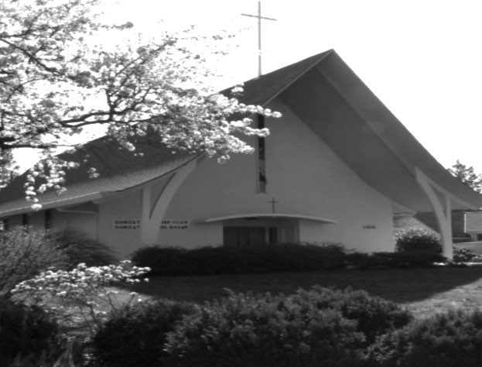
Grace and Peace to you in the NAME of GOD: Father, Son, and Holy Spirit. Amen.
SECOND SUNDAY IN LENT
MARCH 1, 2026
St. Timothy Lutheran Church, Portland, OR
THE LESSONS: Genesis 12:1-4, Psalm 121, Romans 4:1-5, 13-17, John 3:1-17
THE SERMON: “I Love to Tell… What Story…?”
Introduction: Beyond the Finish Line
I’m pretty sure I’ve told this joke before, because it fits the theme for today. A Lutheran was visiting the Vatican and heard about the Sacrament of Reconciliation. Thinking it sounded like a good way to "tune up" his faith, he waited in a long line for hours. Finally, he confessed his sins and burst out of the booth shouting, “I’m perfect! I’m totally sin-free!” A priest nearby tapped his shoulder and whispered: “Sorry, my friend. That’s Pride. Get back in line.”
When I first heard that, I didn't laugh. I didn't laugh because I was that man. I thought the Cross was a giant eraser—one swipe and all my sins were gone. But as I lived, I realized my life hadn't stopped being messy. I still struggled with honesty; I still participated in self-righteous gossip. This is why I love Luther’s idea that we are Simul iustus et peccator. We are Saint and Sinner at the same time—like a compass that points North even while the traveler stumbles in the mud. Salvation isn't a trophy; it’s a lifelong journey. We get so cozy in being "forgiven" that we forget we are meant to be "transformed."
Genesis 12:1-4: Abraham: Moving with the Call
If God wanted a "finished product," He never would have picked Abraham. God doesn’t look for perfection; God looks for obedience. He told Abram: "Go from your country... to the land I will show you."
At 75, most of us want to settle down and retire. Abram moved his feet, he got up and moved. He wasn't a moral superstar—he lied about his wife to save his own skin! He tried to "help" God’s timing by taking matters into his own hands with Hagar and got her pregnant. Yet, his faith was "reckoned as righteousness." Why? Because when the Great I AM called, Abraham got up and went. Faith isn’t a feeling of certainty; it’s the act of putting one foot in front of the other and following wherever God leads.
So often we can’t see the beauty of the Word because there’s so much clutter in our lives. Why is it so hard to stay "on track” with God? It’s because the world is a crowded, chaotic place. We are bombarded by the heavy weight of anxiety and the stinging pressure of "not enough-ness.” We often think the spiritual journey is a straight line—a perfect, ascending staircase. But look at Abram again as a divine work in progress. His journey was full of detours. There were years of silence where it felt like God had closed the map and walked away. In those moments, we are tempted to chart our own course, aren't we? We try to force a destination that isn’t there. Lent is the season where we sit in that uncertainty. We stop trying to "fix" the path and instead, we learn to wait in the stillness until we can feel the nudge of the Spirit again.
Psalm 121: The Keeper of the Way
When the road gets steep, Psalm 121 reminds us to look up and asks, "Where does my help come from?" It doesn’t come from the hills, but from the Maker of the hills—the One who set the foundations of the universe.
Think about a lighthouse. It stands steady and unfazed by the crashing waves or the wrong turns a ship might take. God is our divine constant. He is your "Guardian Light." He doesn’t sleep, meaning the flow of His grace never stops, even when you lose your way. The Psalmist says He is the shade at your right hand. In the ancient Mideastern world, the sun wasn't just a light; it was a burden. It was a heat that could break you. God filters that "harsh glare" of the world so your soul doesn't get scorched by the heat of your own failures. Whether you are coming or going, whether you are in a season of strength—bold and bright—or a season of exhaustion—shadowed and weary—God is holding your hand so your foot does not slip. God is not waiting for you at the finish line; God is walking with you every step of the way.
Romans 4:1-5, 13-17: The Gift of Grace
Our lesson in Romans reminds us of Paul, who was knocked off his high horse by a light so bright it silenced his ego. He realized the world’s "rulebook" is: Do good, and God will like you. But that’s just a distraction. God doesn't want us to be in debt to Him; God’s love is free—no strings attached. God wants to give us a gift.
Abram wasn’t right with God just because he followed laws—the Ten Commandments didn't even exist then! He was right because he trusted the One who makes the promises. That’s why God renamed him Abraham; he was obedient, and God reckoned his faith as righteousness. We Lutherans are often so quiet about our faith that the world can’t hear the message of God’s forgiveness and grace echoing through us. Paul reminds us that grace is the "breath" in our lungs. You don't create the life; you just let the Life move through you.
John 3:1-17: Nicodemus: From Shadow to Sight
Today’s gospel shows us Nicodemus, who came to Jesus at night, full of intellectual "clutter." He’s a Pharisee, a man who has spent his whole life trying to "polish" himself by the rigid standard of the Law. He’s exhausted. Jesus tells him he must be "born from above"—born of the Pneuma, the Wind, the Spirit, the Breath.
Nicodemus tries to understand this with his "earthly brain," asking about wombs and biology. He’s trying to follow a manual when Jesus is asking him to trust the wind. To be born of the Spirit is to realize that you are not the architect; you are the house being built.
But notice Nicodemus’ life trajectory. He starts in the shadows, a muffled presence. Later, in John 7, we see him find his voice, cautiously defending Jesus before the council. Finally, he is there at the cross, no longer hiding, bringing seventy-five pounds of myrrh and aloes to honor the body. The shadow had become a witness. He moved from a private curiosity to a public witness. That is the Lenten journey. It’s not a one-time "event" where you get your "saved" certificate; it’s being "born from above" every time you inhale. It’s the slow, steady process of the Master Craftsman smoothing the rough edges of our hearts until we finally reflect the image of God.
The Call and the Challenge: The Final Word
Our religious practices are just the scaffolding; the building is faith. Abraham, Nicodemus, and Paul were all "lost" at times, yet God used them. Don't sit in the pride of your "purity," or you’ll find yourself at the back of the line again. God doesn’t rely on perfect people because there aren’t any.
Instead, lift your eyes. You won't see your own reflection; you’ll see a lonely hill and a Savior saying, "Father, forgive them." That is the final, resolving word of history. God didn't send His Son to tell us we are failing; He sent Him to bring the world back into His arms. The story isn't over; in fact, the most beautiful chapter is just beginning. Our lessons today call us to be like Abraham, to step out into God’s future. And our hymn challenges us to tell the story of Jesus and his love. We live in a time in which people are hungering and thirsting to hear God’s message of good news. While the world clamors with the sounds of anger, division, and hate, God’s story is a beautiful narrative of love, joy, and peace.
So, let’s tell this story as we rise and sing Hymn 661, because we love to tell God’s story…

