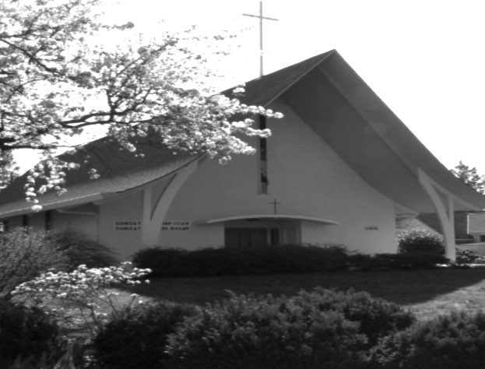
Grace and Peace to you in the NAME of GOD: Father, Son, and Holy Spirit. Amen.
THE RESURRECTION OF OUR LORD
April 5, 2026
St. Timothy Lutheran Church, Portland, OR

THE LESSONS: Acts 10:34-43; Psalm 118:1-2,14-24; Colossians 3:1-4; Matthew 28:1-10

THE SERMON: “The Battle Is… Done!”
Introduction: The Rest of the Story
I often steal the signature line from the late radio commentator, Paul Harvey, who would start his program with a mind-grabbing story and leave you hanging by going to commercial. When he returned to give you the punchline, he’d say, “And now, for the rest of the story.”
That’s the trouble with the Easter story; all of us think we know the “rest of the story.” Well, it certainly isn’t anything like the story Assembies of God Pastor David Cawston once told in his Easter sermon about a man driving down the highway when the Easter Bunny hopped out right in front of him. He swerved, but unfortunately, the rabbit was hit. The basket of eggs and candy went flying. Much to his dismay, the man saw that the Bunny was dead.
A woman driving by stopped and asked what was wrong. He explained, “I feel terrible, I accidentally killed the Easter Bunny. Now there won’t be an Easter because of me.” The woman told him not to worry. She pulled a spray can out of her purse and sprayed the entire contents onto the little furry animal. Miraculously, the Easter Bunny came back to life, jumped up, picked up the candy, waved his paw, and hopped on down the road. Twenty yards away, the hare stopped, turned around, waved, and hopped another twenty yards, turned, and waved again and continued this until the hare was out of sight.
The man was astonished. “What in heaven's name is in your spray can?” The woman turned the can around so he could read the label. It said: “Hair spray. Restores life to dead hair and adds permanent wave.”
Now, that obviously isn’t the “rest of the story.” But I’m using this joke to show how easily we create ideas that obscure the real meaning of Christian holy days. We’ve neglected the reason for the season. Instead of Christ’s resurrection, we’ve adopted a bunny with a permanent wave. Perhaps because we aren't truly hearing the promise of new life with God, we expect chocolate eggs to fill our lives with enough sweetness to help us forget the darkness around us.
But an anonymous author once wrote: “Easter peace does not mean to be in a place where there is no noise or trouble or hard times. It means to be in the midst of those things and still be calm in your heart.”
In the time we are living now, that is the message people need. We live in a world of chaos; yet Easter peace can bring a calm that the world cannot give.
Colossians 3:1-4: Faith vs. Religiosity
When we hear Paul’s words to the Colossians, “If you have been raised with Christ, seek the things that are above... not on things that are on earth,” it’s easy to be skeptical. Some might say, "That’s just 'pie-in-the-sky' junk. We might as well believe in the Easter Bunny.” In fact, Karl Marx wrote: "Religion is the sigh of the oppressed creature, the heart of a heartless world, and the soul of soulless conditions. (Religion) is the opium of the people."
But Paul argues that faith is not mind-numbing drug; faith is living out truth. The trouble with the world today is that we build idols in our minds. In fact, this past week, a minister equated one of our national leaders with Jesus. No human could ever be who Jesus is. Religion becomes pointless when preachers spout nonsence and when we just observe rituals out of habit and our prayers are merely words. Paul saw this in Colossae. People were practicing religion but not living faith.
As we remembered on Maundy Thursday, Jesus gave a new commandment: “Love one another. Just as I have loved you.”Paul is telling us that religiosity—doing things out of duty—is not faith. Faith is elevating rituals into acts of love. It’s transforming the words of prayers into sincere expressions of our deepest hopes. When we love God by serving others, we silence the noise of anger and fear. That’s when we’re truly revealed with Christ in glory.
Psalm 118: The Day the Lord Has Made
If you read the Psalm this morning without thinking, then Paul’s warning applies: don't just set your mind on earthly words; set your mind on heavenly promises. The Psalmist writes: “I shall not die, but I shall live, and recount the deeds of the Lord.” We know the rest of the story. It didn’t end at the cross or in the dark tomb. God did not hand His Son over to death. When you read this Psalm through the lens of the Resurrection, the Holy Spirit reveals deeper truths. We can’t help but sing that God is our strength and our salvation. Today is the day the Lord has made. Because of Easter, we don’t just read the words; we sense God’s living presence in them.
Acts 10:34-43: A Message for Everyone
In the Book of Acts, we see Peter painting this Easter picture for Cornelius, a Roman centurion. Peter explains how Jesus went about doing good, how he was put to death on a tree, and how God raised him on the third day.
This message transformed Cornelius and his entire household. Why? Because they realized that even though they weren’t part of the "original" inner circle, they were now in God’s family. Jesus’ righteousness makes us righteous in God’s eyes.
The message of Easter is this: You are forgiven. And because you are forgiven, you can rise from your defeats, your disappointments, and your fears. God wants us to live—truly live—in the hope that we are His children.
Matthew 28:1-10: The Empty Tomb
This brings us to Matthew’s account of Easter. We know the disciples were locked in a secret room, paralyzed by fear because they didn't yet believe the promise. But then, as the sun was dawning, the women went to the tomb. There was an earthquake, an angel rolled back the stone, and the message rang out: “He is not here; for he has been raised, as he said.”
The Gospel writers—Matthew, Mark, Luke, and John—each give slightly different details about who ran where or who spoke first. But they all agree on the one fact that changes everything: The tomb was empty. The darkness could not hold Him.
The Call and the Challenge
The miracle of Easter isn’t simply that a man came back to life. The miracle is that when we set our minds on Christ, we no longer have to be overwhelmed by the noise and chaos of this world. God shows us that there is a future.
My mentor, Pastor Norm Hammer, used to plead: “Don’t come and lay your garbage bags of troubles at the altar as you hear God’s good news, only to pick them up and take them home with you at the end of the service. Leave your garbage here at the altar.”We’re supposed to live. And we can live indeed! That, my friends, is the rest of the story.
To celebrate this victory over death and the new life we share in Christ, the Spirit might be nudging us to sing of the light that no darkness can overcome and turn to proclaim a song of triumph that has echoed through the centuries, reminding us that the fight is over and the victory is won.
So, in the spirit of the resurrection and the joy of the "rest of the story," let us sing a song of triumph that has echoed through the centuries. Our Hymn for today reminds us that the strife is over, the battle is done, and the victory of life has been won. CHRIST IS RISEN! HE IS RISEN INDEED! Hymn 366, "The Strife Is O'er, the Battle Done."

